IEEE TRANSACTIONS ON NUCLEAR SCIENCE, VOL. 64, NO. 12, DECEMBER 2017 2913

Total Dose Effects and Bias Instabilities of (NH4*)*2S Passivated Ge MOS Capacitors With

|  |  |
| --- | --- |
| Yifei Mu | Hf*x*Zr1−*x*O*y* Thin Films  , Yuxiao Fang, Ce Zhou Zhao, Chun Zhao, Qifeng Lu, Yanfei Qi, Ruowei Yi, |

Li Yang, Ivona Z. Mitrovic, Stephen Taylor, and Paul R. Chalker

***Abstract*—The effects of biased irradiation on Ge MOS capac-itors with Hf*x*Zr1−*x*O*y(*0*.*43 *< x <* 1*)* gate dielectrics have been investigated. These devices were irradiated by a 662-KeV Cs137*γ* -ray radiation source with 0.5 or –0.5 V gate bias. Prior to irradiation exposure, leakage behavior and bias-instability of Hf*x*Zr1−*x*O*y* films were also examined. Gate leakage current density increases with the increasing of Zr composition in gate oxide. In addition, Zr-containing dielectrics under positive bias (PB) exhibited more oxide negative trapped charges than that of HfO2, which suggested that the oxygen-vacancy concen-tration in Hf*x*Zr1−*x*O*y* was increased by the addition of Zr. Larger flat-band voltage shifts (*V*FB*)* were extracted under positive biased irradiation than the bias only results. The results indicate that radiation-induced interface traps (*N*it*)* are the dominant factor for*V*FB in HfO2 thin films, whereas the radi-ation response for Zr-containing dielectrics under PB was mainly due to oxide traps. Under negative biased irradiation,*V*FB was attributed to the combined effect of the net oxide trapped charges and the passivation of Ge dangling bonds at the Ge/high-k interface. Additionally, both bias-induced and radiation-induced charge trapping have a crucial effect on radiation response of Hf*x*Zr1−*x*O*y* at each dose level. Hf*x*Zr1−*x*O*y* is identified as a promising gate dielectric for advanced complementary metal–oxide–semiconductor technologies.**

**oxide trapped charges, total dose effect.**  ***Index***  ***Terms*—Hf*x*Zr1−*x*O*y*,**  **germanium,**  **interface**  **traps,**

gate capacitance for better channel control, while maintaining low leakage current, high-*k* gate dielectric material has been employed to replace SiO2 for nanoscale CMOS device applications [1]–[3]. Because of its relative high band gap and compatibility in contact with channel region, HfO2 has been considered as a promising candidate for high-*k* gate dielectrics in CMOS technology [4], [5]. However, the dielectric constant of HfO2 is not high enough to obtain the continued scaling of advanced metal–oxide–semiconductor field-effect transistors (MOSFETs) [6]. ZrO2 offers the benefit of a higher dielectric constant due to easier stabilization of its tetragonal phase as opposed to the monoclinic phase in crystallized HfO2. In addition, HfO2 and ZrO2 are chemically similar and thus completely miscible in solid state [7], [8]. It has been reported that the addition of ZrO2 into HfO2 gate dielectric stabilizes the tetragonal phase and enhances the dielectric constant [9]. Hf*x*Zr1−*x*O*y* dielectric is thus an attractive candidate for advanced gate-stack applications. On the other hand, germanium (Ge) is of great interest as a promising channel material for future MOSFETs because it processes higher intrinsic carrier mobility (four times for hole and two times for electron mobility) compared with that of silicon (Si). Likewise, Ge applications can

|  |  |  |  |  |  |  |  |
| --- | --- | --- | --- | --- | --- | --- | --- |
| **A** | I. INTRODUCTION | | | | | | offer high compatibility with conventional Si integration |
| technologies [10], [11]. However, a fundamental issue of the |
| S | THE | scaling | of | complementary | metal–oxide– | application of Ge in CMOS technology is that Ge easily |
| forms unstable oxides GeO*x* on the surfaces, which can result |
| semiconductor (CMOS) devices requires the increase in | | | | | |
| in a poor quality interface between the Ge channel and high-*k* |

Manuscript received September 3, 2017; revised October 10, 2017; accepted October 11, 2017. Date of publication November 1, 2017; date of current version December 14, 2017. This work was supported in part by the National Natural and Science Foundation of China under Grant 11375146 and in part by the platform promotion for Suzhou Municipal Key Laboratory for New Energy Techniques *(Corresponding author: Ce Zhou Zhao)*.

Y. Mu, Y. Fang, Q. Lu, I. Z. Mitrovic, and S. Taylor are with the Department of Electrical Engineering and Electronics, University of Liverpool, Liverpool L69 3GJ, U.K. (e-mail: yuxiao.fang@xjtlu.edu.cn).

C. Z. Zhao, C. Zhao, and Y. Qi are with the Department of Electrical and Electronic Engineering, Xi’an Jiaotong-Liverpool University, Suzhou 215123, China (e-mail: cezhou.zhao@xjtlu.edu.cn).

R. Yi is with the Department of Chemistry, University of Liverpool, Liverpool L69 7ZD, U.K.

L. Yang is with the Department of Chemistry, Xi’an Jiaotong-Liverpool University, Suzhou 215123, China.

P. R. Chalker is with the Center for Materials and Structures, School of Engineering, University of Liverpool, Liverpool L69 3GH, U.K.

Color versions of one or more of the figures in this paper are available online at http://ieeexplore.ieee.org.

Digital Object Identifier 10.1109/TNS.2017.2768566

dielectrics and low carrier mobility in the channel. This technological issue has been overcome by the passivation of Ge surface, which can prevent oxidation formation during device processing [12]–[14]. It has been reported that sulfur passivation of germanium is very effective in preventing the formation of the GeO*x* at the interface, which can lead to superior Ge gate-stack [15], [16]. The reduction of interface defects is attributed to the formation of Ge-S bonds and GeS species at the Ge/high-*k* surface. The electrical characteristics of Ge MOS devices with Hf*x*Zr1−*x*O*y* gate dielectric have been investigated in recent studies [6]. It has been reported that the interface trap density and subthreshold swing of Ge MOSFETs are clearly improved by the addition of ZrO2 into HfO2 gate dielectric. Therefore, Ge devices with Hf*x*Zr1−*x*O*y* gates could be promising candidates for advanced CMOS technologies and integrated circuits.

0018-9499 © 2017 IEEE. Personal use is permitted, but republication/redistribution requires IEEE permission. See http://www.ieee.org/publications_standards/publications/rights/index.html for more information.

2914 IEEE TRANSACTIONS ON NUCLEAR SCIENCE, VOL. 64, NO. 12, DECEMBER 2017

Advanced MOS devices employed in space applications are TABLE I

subjected to radiation exposure which can lead to device degra-dation and circuit failures. Several studies suggest that, unlike conventional Si/SiO2 case, a significant density of trapped charges can be observed in high-*k* dielectrics under long-term radiation and bias conditions [17]–[21]. Qualification

EDS MEASUREMENTS OF HF*x*ZR1−*x*O*y* THIN FILMS ON GE (100) SUBSTRATES. FOR ALD DEPOSITION SEQUENCE, A: HF:ZR = 1:1 AND B: HF:ZR = 3:1



of high-*k* dielectrics for space applications needs far more 

studies to evaluate charge trapping behavior and reliability performance. Consequently, it is important to characterize the



|  |  |
| --- | --- |
| radiation response of Ge MOS devices with Hf*x*Zr1−*x*O*y*. However, very little research has been done on the total dose  effects of these devices. In this paper, we have investigated |  |

the total ionizing dose radiation effect on Hf*x*Zr1−*x*O*y* thin films prepared by atomic layer deposition (ALD) deposited

on (NH4*)*2S passivated Ge substrate. The measurements

were carried out under continuous gamma-ray exposure

with positive and negative bias. The bias instability of the

Hf*x*Zr1−*x*O*y* gate dielectric with various ZrO2 content are also studied.

II. EXPERIMENTAL DETAILS

The samples used in this paper were n-type ger-

manium (100) wafers with a doping concentration of

∼ 1015cm−3. Prior to gate-stack fabrication, germanium wafers were initially degreased by ultrasonic bath in acetone

for 10 min, and then the degreased samples were ultra-

sonic cleaned in isopropyl alcohol for 10 min to remove

grease or oil [15], [16]. The native oxides were then removed

using a solution of HF: deionized water (1:50) for 30 s.

The finally treatment involved a 15 min (NH4*)*2S solution

(0.1 mol/L) soak and deionized water rinse in order to passi-

vate the Ge interface [15], [16]. Hf*x*Zr1−*x*O*y* thin films with various Zr/Hf ratio, were prepared at a wafer temperature

of 200 °C using ALD. Hf[(CH3*)*2N]4, Zr[(CH3*)*2N]4, and

deionized water served as the Hf precursor, Zr precursor,

and oxygen source. Composition and thickness of the thin

films were controlled by the various ratios of Zr:Hf precur-

sor cycles. Aluminum electrodes were deposited by electron

beam evaporation with 0.07 mm2gate area. The physical

thicknesses of HfO2, Hf0*.*6Zr0*.*4O2, and Hf0*.*43Zr0*.*57O2 were

20.5, 21.3, and 21.1 nm, respectively, as measured by spectro-

scopic ellipsometry. The elemental analyses of the deposited

films were measured using an Oxford Instruments Energy

Dispersive Spectrometer (EDS).

To investigate their radiation response, devices were irradi-

ated at an on-site radiation response probe station system with

a 662-KeV Cs137*γ* -ray radiation source [22]. After taking into

account the dose enhancement effect, the dose rate of HfO2

and Hf*x*Zr1−*x*O*y* thin films was 0*.*119 × 10−3krad/s (SiO2*)*. A total dose up to 45 krad (SiO2*)* was applied to devices

with a constant gate bias of 0.5 or −0.5 V. During the biased irradiation, oxide and interface charge trapping behav-

iors of Hf*x*Zr1−*x*O*y* thin films were revealed by analysis of

Capacitance–Voltage (*C*–*V)* curves at the frequency of 1 MHz.

The *C*–*V* and Current–Voltage (*J*–*V)* measurements were

carried out using a HP 4284 Precision LCR meter and an

Agilent B1500A Semiconductor Device Analyzer.

|  |  |
| --- | --- |
|  |  |

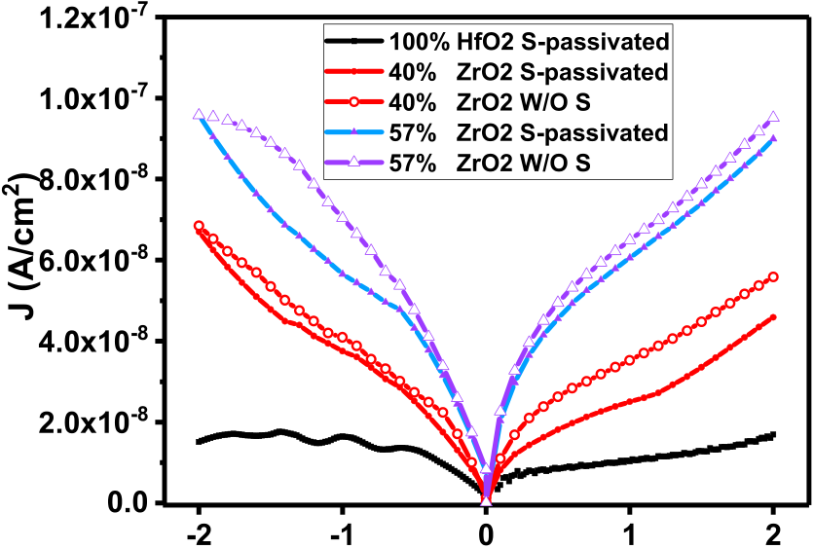



Fig. 1. dielectrics on Ge MOS devices. The gate leakage density is increased with Current density–voltage (*J*–*V )* characteristics for Hf*x*Zr1−*x*O*y*

the increasing of Zr compositions in Hf*x*Zr1−*x*O*y* gate oxide.

III. RESULTS AND DISCUSSION

*A. Preradiation and Prebias Characteristics*

are shown in Table I. Sample A was grown with the Hf:Zr The atomic ratios of the Hf*x*Zr1−*x*O*y* thin films investigated

deposition ratio of 1:1 (i.e., every HfO2–H2O cycle followed by a ZrO2–H2O cycle), while the deposition ratio for sample B was 3:1. It can be observed that the atomic ratios of the thin films are 0.43:0.57 and 0.6:0.4 (Hf:Zr) for sample A and sample B, respectively. This indicates that the deposition rate of ZrO2 is higher than that of HfO2. Moreover, no measurable impurity has been observed in the deposited films.

dielectrics on their leakage behavior is exhibited in Fig. 1. The impact of Zr composition in Hf*x*Zr1−*x*O*y*  gate

It is shown that the gate leakage density is increased with the increasing of Zr composition in gate oxide. This can be explained by the smaller band gap and lower band offset of ZrO2 compared with HfO2. The higher leakage current density of ZrO2 is identical to previous reports for Hf*x*Zr1−*x*O*y* dielectric deposited on Si substrate [7]. The effects of the surface passivation of Ge on the leakage behavior in Hf*x*Zr1−*x*O*y* MOS capacitors are also shown in Fig. 1. It can be observed that the leakage current is decreased after the sulfur treatment of Ge surface. Mao [23] has reported that the density and location of interface traps at dielectric/Si surface have significant effects on gate leakage current. It was also

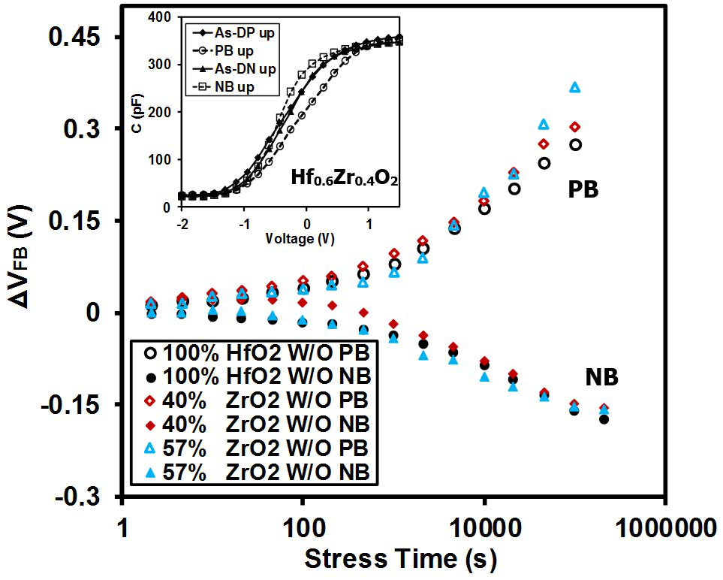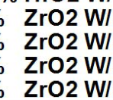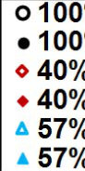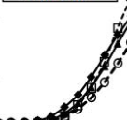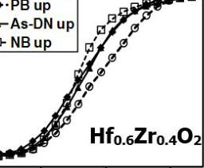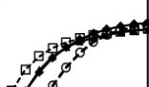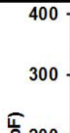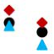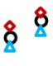

MU *et al.*: TOTAL DOSE EFFECTS AND BIAS INSTABILITIES OF (NH4*)*2S PASSIVATED Ge MOS CAPACITORS 2915

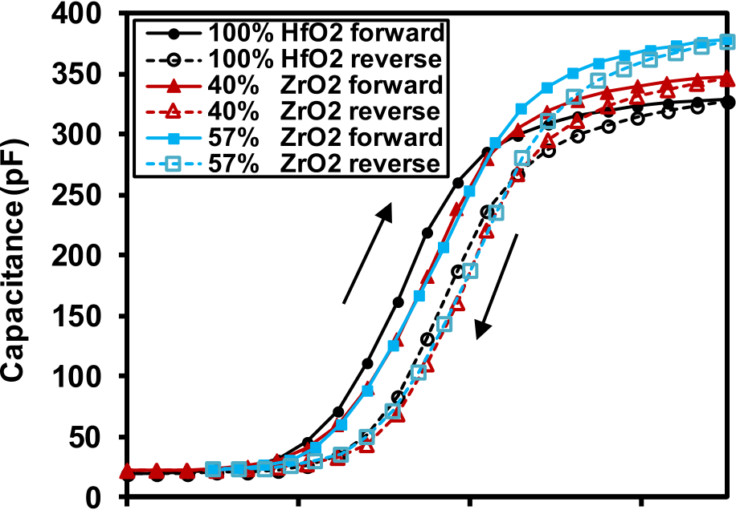

|  |  |  |  |
| --- | --- | --- | --- |
|  |  |  |  |



Fig. 2. *C*–*V* characteristics of Ge MOS capacitors with HfO2, Hf0*.*6Zr0*.*4O2, and Hf0*.*43Zr0*.*57O2 gate dielectrics. The permittivity of gate oxide increases with the increasing of ZrO2 compositions in Hf*x*Zr1−*x*O*y* dielectrics.

reported that the passivation of Ge surface can result in the formation of high-*k*/S/Ge stack, thus decreasing the interface traps [15]. Therefore, the improved leakage characteristics in sulfur-passivated samples can be attributed to the reduction of interface trap density. However, the leakage behavior of the MOS capacitors cannot fully identify the impact of sulfur treatment and Zr composition on Ge interface states. It is necessary to investigate the interface defects by evaluating bias instability of the MOS capacitors via their *C*–*V* characteristics. Fig. 2 shows the *C*–*V* characteristics of Ge MOS capacitors with various Zr-compositions of Hf*x*Zr1−*x*O*y* gate dielectrics. The result indicates that higher dielectric constants can be observed in Zr-doped Hf*x*Zr1−*x*O*y* thin films. It can be understood that the addition of ZrO2 into HfO2 gate oxide stabilizes the tetragonal phase and shows higher dielectric constant, whereas the HfO2 exhibits monoclinic phase as opposite to ZrO2 [7], [8]. Smaller hysteresis was extracted from the *C*–*V* curves of MOS capacitors with Hf0*.*43Zr0*.*57O2 and Hf0*.*6Zr0*.*4O2 dielectrics. The hysteresis between the ramped up and ramped down of *C*–*V* curves was originated from part of the defects in high-*k* dielectrics which can be repeatedly neutralized and recharged by charge injection from the substrate [24], [25]. Therefore, the results imply that Zr-containing HfO2 gate dielectrics has a fewer cyclic charged traps or border traps compared with HfO2. In addition, the gate ZrO2 doped dielectrics shows a positive flat-band voltage shift (*V*FB*)* compared with HfO2, which may be attributable to the presence of pre-existing electron traps or the lack of positive charges in ZrO2.

*B. Bias Instability*

As discussed in our earlier work, the*V*FB of irradiated devices under electric field is attributed to the combined effect of radiation-induced and bias-induced charge trapping in dielectrics [26]. In order to separate the bias-instability and radiation-caused shifts, the*V*FB of the devices under electric field without radiation exposure was observed [19], [27], [28].

Fig. 3. without irradiation as a function of stress time for Ge MOS capacitors with Flat-band voltage shifts (*V*FB*)* induced by −0.5 or 0.5 V bias

Hf*x*Zr1−*x*O*y* gate dielectrics. Under PB, larger*V*FB was obtained from Zr-containing devices after a stress time of 130 h. Under NB, no significant discrepancy of*V*FB can be observed. The *C*–*V* plots of the Ge MOS capacitors with Hf0*.*6Zr0*.*4O2 before and after pure bias without irradiation are shown in the inset.

Fig. 3 illustrates the*V*FB of Ge MOS capacitors with various Zr-containing Hf*x*Zr1−*x*O*y* gate dielectrics. The*V*FB was estimated by *C*–*V* measurements under −0.5 or 0.5 V without irradiation (W/O). The inset of Fig. 3 illustrates the represen-tative *C*–*V* curves of Hf0*.*6Zr0*.*4O2 before and after different bias conditions. Under positive bias (PB), Hf*x*Zr1−*x*O*y* with various Zr compositions all exhibited positive*V*FB up to 0.38 V. As the*V*FB was attributed to the combined effect of net oxide trapped charges and interface traps at the Ge/high-*k* interface, this positive*V*FB of Hf*x*Zr1−*x*O*y* gate dielectrics was induced by electron tunneling from the Ge substrate to form negatively charged states and/or the build-up of interface traps. In addition, the*V*FB of the capacitors increases with the increase of Zr composition in Hf*x*Zr1−*x*O*y*. This result indicates that HfO2 dielectrics exhibits relative low electron trap density or interface trap density compared with that of ZrO2. Negative bias (NB) applied on the Hf*x*Zr1−*x*O*y* capacitors for more than 130 h without irradiation resulted in negative*V*FB up to −0.18 V. No significant discrepancy of*V*FB was observed for Hf*x*Zr1−*x*O*y* thin films with various Zr compositions. This can be explained by an approximately equal density of both net positive oxide trapped charges and interface charges for HfO2 and ZrO2. However, as shown in the following results (Fig. 4), it seems more probable that the combined effect of oxide and interface charge trapping is the dominant cause for the identical*V*FB obtained under NB. In order to determine the charge trapping behavior in Hf*x*Zr1−*x*O*y* gate dielectrics under pure bias conditions, oxide trap density (*N*ot*)* and interface trap density (*N*it*)* were calculated from the *C*–*V* curves used in the extraction of *V*FB in Fig. 3. Felix *et al.* [21] reported that the mid-gap voltage shift (*V*mg*)* of MOS capacitors is mainly affected by the oxide trapped charges in dielectrics during the irradiation exposure [15], [16]. In other words, the variations of net oxide



2916 IEEE TRANSACTIONS ON NUCLEAR SCIENCE, VOL. 64, NO. 12, DECEMBER 2017

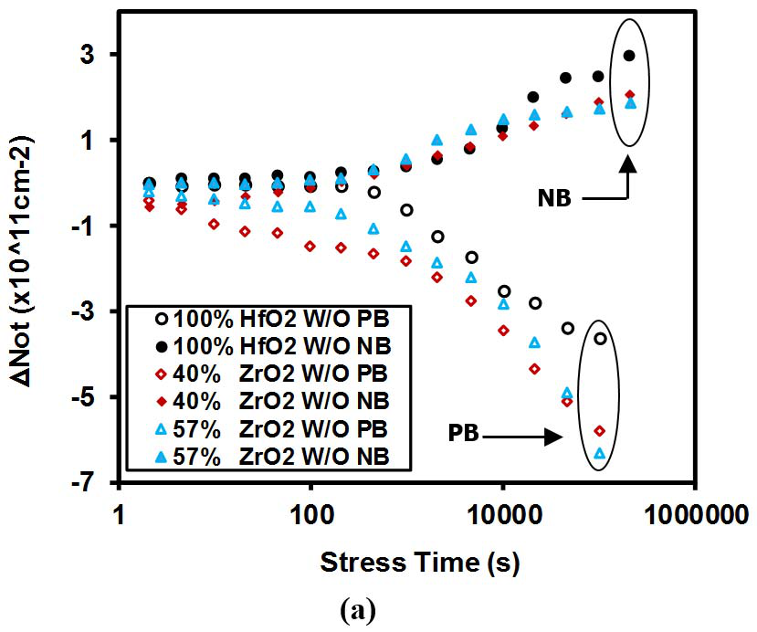

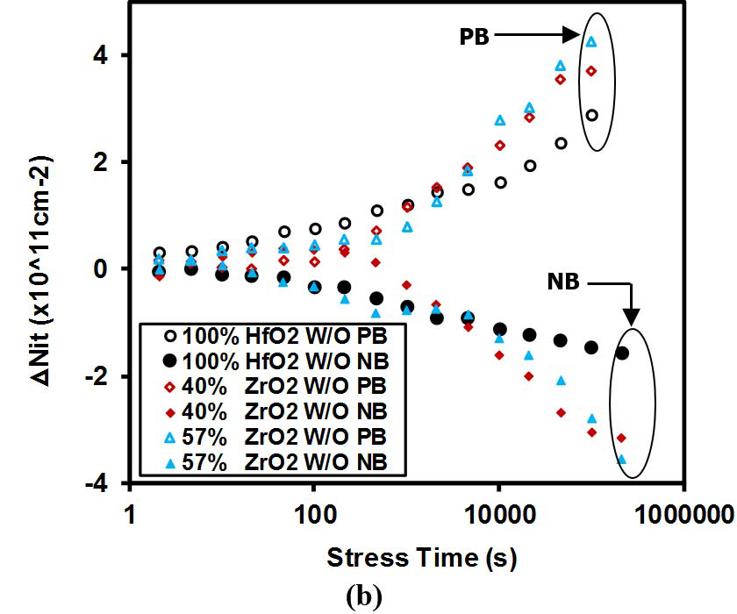

Fig. 4. (a)*N*ot and (b)*N*it as a function of stress time for Ge MOS capacitors with HfO2, Hf0*.*6Zr0*.*4O2, and Hf0*.*43Zr0*.*57O2 gate dielectrics under −0.5 or 0.5 V bias without irradiation exposure.*N*ot was extracted from the mid-gap voltage shift of *C*–*V* curves of Ge devices.*N*it was calculated from*V*FB and mid-gap voltage shift of Ge devices.

trapped charge density (*N*ot*)* of Hf*x*Zr1−*x*O*y* in this paper can be calculated from the*V*mg of Ge MOS capacitors. Using the value of*V*mg, the*N*ot can be estimated by (1) [15]

*N*ot = −*C*ox*V*mg (1)

where*V*mg is the mid-gap voltage shifts obtained from *C*–*V* curves, *C*ox is the gate capacitance of MOS capacitors, −*q* is the electronic charge, and A is the electrode area. The gate capacitance of MOS capacitors was obtained from *C*–*V* measurement. The electronic charge is fixed and the electrode area is determined by the evaporation processes before the irradiation exposure. Therefore, the*N*ot can be calculated by the variations of mid-gap voltage.

Similarly, it was also reported that flat-band voltage shift (*V*FB*)* was determined by the combined effect of oxide the effects of interface trapped charges on*V*FB, the effects trapped charges and interface trapped charges. To evaluate

from oxide trapped charges need to be removed. As reported in the literature, the interface trap densities can be cal-culated from mid-gap-to-flatband stretchout of *C*–*V* curves by (2) [15], [26]

*N*it =*C*ox*(V* FB −*V*mg*)*  (2)

where*V*FB is the flat-band voltage shift obtained from *C*–*V* curves,*V*mg is the mid-gap voltage shifts obtained from *C*–*V* curves, *C*ox is the gate capacitance of MOS capacitors, and −*q* is the electronic charge, and A is the electrode area. Therefore, the*N*it can be calculated by the variations of*V*mg and*V*FB.

Fig. 4(a) shows the*N*ot as a function of stress time for both PB and NB. The result indicates that the density of negative oxide trapped charges increases in magnitude with increasing Zr composition in Hf*x*Zr1−*x*O*y* during PB. Under PB, electrons are injected from Ge substrate, the elec-tron traps near the interface can trap the tunneling electrons and forming negative oxide trapped charges. These negative oxide trapped charges near the Ge/dielectric interface would have significant effect on mid-gap voltage and*N*ot. There-fore, the higher*N*ot of ZrO2 indicates that the negative oxide trap density in ZrO2 is higher than that of HfO2. It was also reported that the possible oxide trap centers in HfO2 and ZrO2 are related to oxygen vacancies and inter-stitials (O0/O−*)* [29]. Since the oxygen vacancies in high-*k* dielectrics behave as negative oxide traps, the larger*N*ot of Zr-containing dielectrics under PB can be attributed to the higher density of oxygen vacancies in ZrO2.

With regard to NB,*N*ot of HfO2 was larger than that of Zr-containing Hf*x*Zr1−*x*O*y*. The result indicates that the den-sity of positive oxide trapped charges decrease with increasing are injected from Ge substrate, the pre-existing hole traps near Zr composition in Hf*x*Zr1−*x*O*y* during PB. Under PB, holes the interface can trap the tunneling holes and forming positive oxide trapped charges. The result indicates that more pre-existing hole traps are located in HfO2 compared with ZrO2. In summary, larger*N*ot for Zr-containing dielectrics under NB is attributed to the higher density of oxygen vacancies in ZrO2, while higher*N*ot for HfO2 under PB can be attribute to the larger density of pre-existing hole traps in HfO2. Fig. 4(b) shows the*N*it for Ge MOS capacitors with Hf*x*Zr1−*x*O*y* gate dielectrics under PB and NB. The interface trap density of Hf*x*Zr1−*x*O*y* with various Zr compositions was all increased during PB. This can be attributed to the build-up of Ge dangling bonds at Ge/dielectrics interface. It has been reported that the passivation of Ge surface by sulfide can result in Ge-S bonds and thus decrease the interface traps [12], [16]. Moreover, it is suggested that H+protons generated at the anode by PB can drift to the Ge interface and break the passivated Ge-S bonds, as shown in Fig. 5 [12], [27], [30]. One possible reaction of the formation of an interface trap is shown

Ge − S + 2H+➜ Ge++ H2S (3)

therefore, the depassivation of passivated Ge-S bonds under PB can lead to an increase in interface trap density for

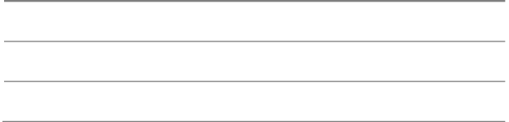

MU *et al.*: TOTAL DOSE EFFECTS AND BIAS INSTABILITIES OF (NH4*)*2S PASSIVATED Ge MOS CAPACITORS 2917

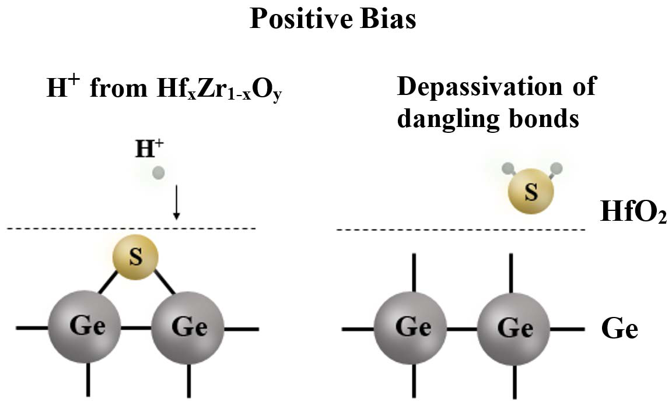

Fig. 5. showing depassivation process of Ge-S bonds. Under PB, H+ions can be Schematic of Ge MOS capacitors with Hf*x*Zr1−*x*O*y* dielectrics

generated at the anode and drift to the Ge interface to break the passivated Ge-S bonds [28], [30].

Ge MOS capacitors. In addition, more interface traps were generated in Zr-doped Hf*x*Zr1−*x*O*y* compared to HfO2. The larger*N*it of Zr containing Hf*x*Zr1−*x*O*y* suggested that ZrO2 tended to present more hydrogen-related species than HfO2. With regard to NB,*N*it of Hf*x*Zr1−*x*O*y* with various Zr compositions are also increases in magnitude, but has a negative sign. In this case, Ge dangling bonds at the interface were passivated. Moreover, it can be observed that more passi-vated dangling bonds are generated in Zr-doped Hf*x*Zr1−*x*O*y*. However, the source for passivation and related mechanisms are not fully understood yet. The difference of*N*it between the different devices suggested that the source for passivation of dangling bonds was likely from the oxide, but not hydrogen in Ge.

Interface trap density (*N*it*)* of the pristine oxides is cal-culated by the conductance method proposed by Nicollian and Goetzberger [31] in 1967. The technique is based on measuring the equivalent parallel conductance G*p* of an MOS capacitor as a function of bias voltage and frequency. The conductance, representing the loss mechanism due to interface trap capture and emission of carriers, is a measure of the interface trap density.

*C*–*V* curves were measured first to determine the mid-gap voltage and oxide capacitance (*C*ox*)*. Then, the conductance–frequency (*Gm*– *f )* curves and capacitance–frequency (*Cm*– *f )* curves of Hf*x*Zr1−*x*O*y* thin films were measured at determined mid-gap voltage. The frequency range was from 15 kHz to 1 MHz. All curves were measured using an HP 4284 Precision LCR meter. The*G p ω*was calculated by (4) [32]

*G p ω*= *G*2*m* + *ω*2*(C*ox − *Cm)*2 *ωGmC*2 ox (4)

where *ω* = 2*π f* , *Gm* is the measured conductance, *C*ox is the oxide capacitance, and *Cm* is the measured capacitance. Then, an approximate expression giving the interface trap density in terms of the measured maximum conductance is given

|  |  |  |  |  |
| --- | --- | --- | --- | --- |
| by (5) [31] | *N*it ≈2*.*5 | �*G p* | �max | (5) |

TABLE II

CALCULATED *N*it OF HF*x*ZR1−*x*O*y* THIN FILMS AT −1.8 V

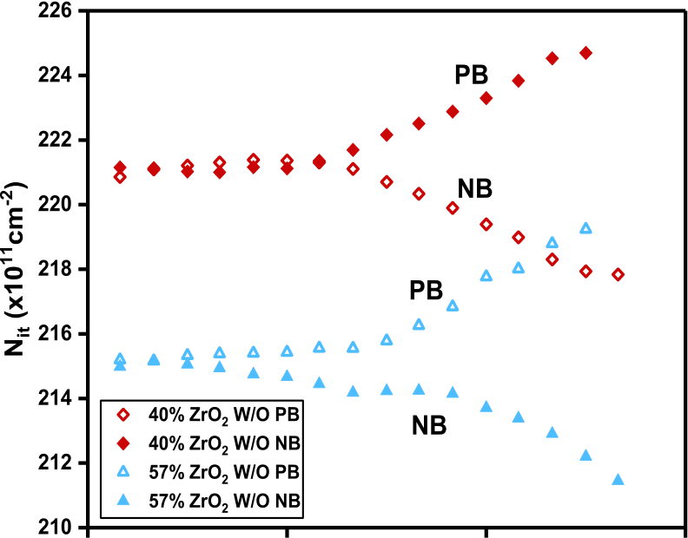



|  |  |  |
| --- | --- | --- |
|  |  |  |



Fig. 6. *N*it as function of stress time for Hf*x*Zr1−*x*O*y* S-passivated thin films under −0.5 or 0.5 V bias without irradiation.

where *N*it is the interface trap density of the pristine oxides. The calculated *N*it are listed in Table II.

Table II indicates that the interface trap density increases with the increasing of Zr composition in gate oxide. The result has a good agreement with the discussion of leakage behavior, the improved leakage characteristics in sulfur passivated and Zr contained samples can be attributed to the reduction of interface trap density. In order to further identify the variation of *N*it, the *N*it as a function of stress time for Hf*x*Zr1−*x*O*y* S-passivated thin films under −0.5 or 0.5 V electric field without radiation was shown in Fig. 6. Similar to the result obtained in Fig 4(b), the *N*it of Hf*x*Zr1−*x*O*y* with various Zr compositions was all increased during PB, while the

magnitude during NB. *N*it of the Hf*x*Zr1−*x*O*y* MOS capacitor was all increased in

*C. Biased Irradiation Response*

A total dose up to 45 krad (SiO2*)* was applied to devices with a constant gate bias of 0.5 or −0.5 V. This paper has been focused only on the relative low-dose-rate radiation response of Ge MOS capacitors with Hf*x*Zr1−*x*O*y*. That is because the advanced microelectronics devices and circuits used in aerospace engineering are unavoidably exposed to space-like radiation, which has a relatively low radiation dose rate at 10−5−10−9krad (SiO2*)*/s. Therefore, the dose absorption rate for dielectrics in this paper is 0*.*119×10−3krad/s (SiO2*)*. However, if a total dose of 1 Mrad (SiO2*)* is applied to Hf*x*Zr1−*x*O*y* thin films under the present radiation source, more than 90 days gamma-ray radiation exposure needs to be performed at this stage. Some uncertain risks are able to have

2918 IEEE TRANSACTIONS ON NUCLEAR SCIENCE, VOL. 64, NO. 12, DECEMBER 2017

significant effects to the on-site measurements system during the relative long-term test, such as probe shifts, uncertain temperature and humidity. The stress voltage and the sweeping voltage were alternately applied to the MOS device during the biased irradiation tests. The irradiation exposure was unin-terrupted during measurement. During the biased irradiation, the *C*–*V* measurements were employed to investigate the dose level. The *C*–*V* curves were measured by an on-site charge trapping mechanism of Hf*x*Zr1−*x*O*y* film at each total radiation response testing system at room temperature.

Fig. 7(a) shows the*V*FB for Ge MOS capacitors with various Hf*x*Zr1−*x*O*y* dielectrics irradiated to 45 krad (SiO2*)* total dose at 0.5, −0.5, and 0 V. The inset of Fig. 7(a) illustrates representative *C*–*V* curves of Hf0*.*6Zr0*.*4O2 before and after biased irradiation. Positive biased irradiation (PBI) on the devices for more than 130 h resulted in positive*V*FB up to 0.58 V. Comparing to the result obtained from Fig. 3, larger*V*FB was extracted under radiation exposure for HfO2 and Hf0*.*6Zr0*.*4O2. However, the*V*FB of Ge MOS capacitors with Hf0*.*43Zr0*.*57O2 thin films after PBI exposure is not changed significant compared to that of pure PB. In addition, the*V*FB of the irradiated capacitors under PBI decreased with the increasing of Zr composition in Hf*x*Zr1−*x*O*y*. On the other hand, the*V*FB of the irradiated capacitors under PBI decreased with the increasing of Zr composition in Hf*x*Zr1−*x*O*y*, which has an opposite trend compared with that of un-irradiated capacitors. Since the radiation-induced*V*FB of Hf*x*Zr1−*x*O*y* dielectrics is determined by the density of oxide traps and interface states, the related charge trapping behavior is investigated and shown in Fig. 7(b) and (c), respectively.

exhibited the presence of net negative oxide trapped charges as Under PBI, Hf*x*Zr1−*x*O*y* with various Zr compositions all

indicated in Fig. 7(b). Values of these*N*ot were larger than the pure PB results in Fig. 4(a). This enhancement was mainly caused by the net radiation-induced negative trapped charges in Hf*x*Zr1−*x*O*y*. However, the effect of oxide trapped charges to devices is more significant when the location of these charges are closer to the high-*k*/Ge interface, and the radiation-induced holes are likely to transport to high-*k*/Ge interface under PB [33]. The PBI exposed to Hf*x*Zr1−*x*O*y* dielectrics is expected to induce more hole trapping. Therefore, the presence of net negative trapped charge during PBI suggests that the density of electron traps in Hf*x*Zr1−*x*O*y* is much larger than hole traps. On the other hand, similar to the results in Fig. 4(a), the density of negative oxide trapped charge increases with increasing Zr composition in Hf*x*Zr1−*x*O*y*. These results point to the fact that more oxygen-vacancy are located in ZrO2 compared with HfO2, which was observed in Fig. 4(a). The*N*it of the Ge MOS capacitors under PBI is shown in Fig. 7(c). Hf*x*Zr1−*x*O*y* with various Zr compositions all exhibited the build-up of Ge dangling bonds. Under PBI, electron-hole pairs can be generated and transported toward Ge substrate. During the transportation of radiation-induced holes, H+protons can be released from the Hf*x*Zr1−*x*O*y* dielectrics, Hf-H, Zr-H bonds, and suboxide bonds [27]. As discussed in Fig. 4(b), these H+protons move to the Ge interface and break the passivated Ge-S bonds, forming Ge dangling bonds.

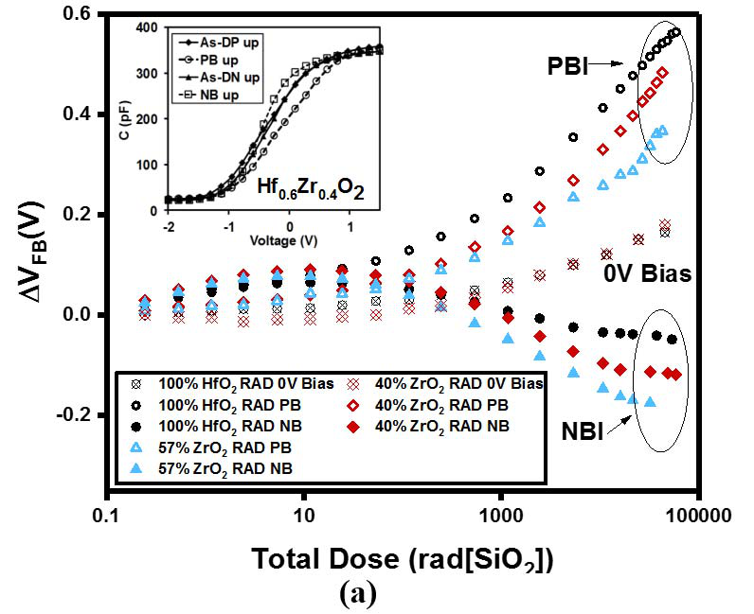

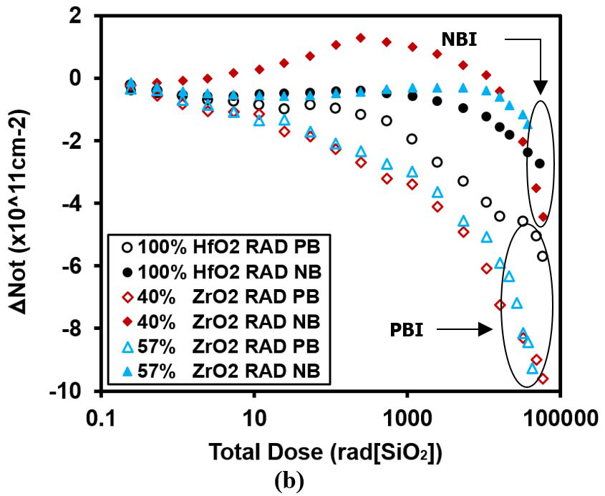

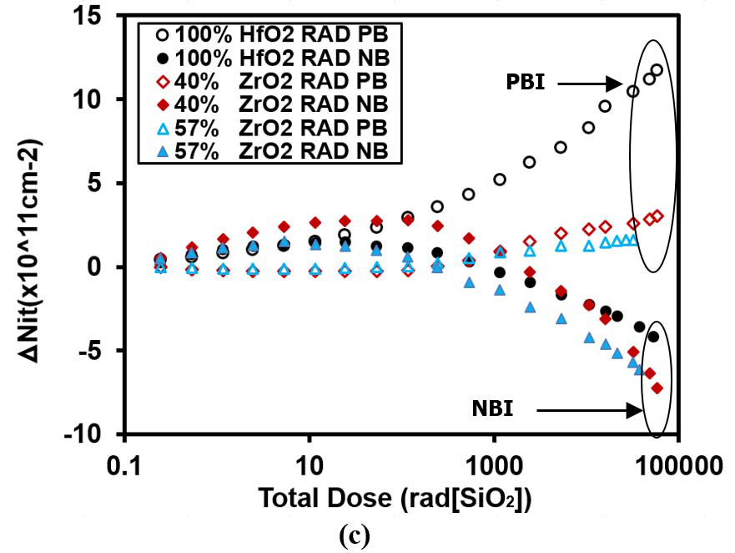

Fig. 7. (a)*V*FB, (b)*N*ot, and (c)*N*it as a function of total dose for Ge MOS capacitors with Hf*x*Zr1−*x*O*y* gate dielectrics under −0.5 or 0.5 V biased irradiation. The inset of (a): *C*–*V* plots of the Ge MOS capacitors

with Hf0*.*6Zr0*.*4O2 before and after biased irradiation.*V*FBand*N*ot were extracted from the flat-band and mid-gap voltage shift of *C*–*V* curves,

respectively.*N*it was calculated from the*V*FB and mid-gap voltage shift of irradiated Ge devices.

Besides, the irradiation exposure can also directly break the

Hf-H, Zr-H dangling bonds, or other bonds associated with

hydrogen. The*N*it of HfO2 in Fig. 7(c) is larger than

MU *et al.*: TOTAL DOSE EFFECTS AND BIAS INSTABILITIES OF (NH4*)*2S PASSIVATED Ge MOS CAPACITORS 2919

it is observed without irradiation, whereas no significant discrepancy can be found for Zr-doped Hf*x*Zr1−*x*O*y*. The results indicated that more H+protons were generated in HfO2 during PBI than that of ZrO2, which was in contrast to the pure PB results. The results also suggested that more radiation-induced holes were generated in HfO2, leading to higher concentration of H+protons during the transportation of holes. Another possible explanation is that Zr-H bond has a higher bond energy, meaning that the Zr-H bonds in ZrO2 are less susceptible to breaking by irradiation exposure and exhibited a lower density of H+protons. Considering the results obtained in Fig. 7(a)–(c), the large radiation-induced *N*it under PBI, is the predominant cause for*V*FB in Ge MOS capacitors with HfO2. Conversely, the radiation response for Zr-containing dielectrics under PB is mostly affected by oxide traps. Comparing to the results evaluated in our previous study, the*V*FB evaluated in HfO2 Ge devices is 7–8 times larger than that of Si devices, which is attributable to the large density of interface traps at the Hf*x*Zr1−*x*O*y*/Ge interface that can result in significant effects on*V*FB.

*V*FB,*N*ot, and*N*it of the Ge MOS capacitors under negative biased irradiation (NBI) were also pre-sented in Fig. 7(a)–(c). After a total dose exposure up to 45 krad (SiO2*)*, a maximum*V*FB of −0.19 V was observed, which was comparable to the results extracted in Fig. 3. The *V*FB of the irradiated capacitors increased in terms of mag-nitude with the increasing of Zr composition in Hf*x*Zr1−*x*O*y*. As discussed above, this trend is likely associated with the combined effect of oxide and interface traps. In contrast to bias effects alone, the*N*ot of Hf*x*Zr1−*x*O*y* dielectrics under NBI, indicated the presence of net negative oxide trapped charge after the total dose of 10 krad. Under NBI, the*N*ot of Hf0*.*6Zr0*.*4O2 increases when the total dose is smaller than 1 krad and decreases when the total dose is larger than 1 krad. This trend is likely associated with the combined effect of radiation-induced negative oxide traps and bias-induced positive oxide traps under NBI.

Comparing to the result of*N*ot for Hf0*.*6Zr0*.*4O2 extracted under pure bias in Fig. 4(a), the results in Fig. 7(b) indi-cated the presence of negative oxide trapped charges. For Hf0*.*6Zr0*.*4O2 thin films, the accumulation of net positive charges was observed at a total dose smaller than 1 krad. However, the density of the net positive charges in Fig. 7(b) was lower than it was observed in Fig. 4(a). The result suggested that both bias-induced hole traps and radiation-induced electron traps dominated the oxide charge trapping of Hf0*.*6Zr0*.*4O2 under NBI at low dose level. At a total dose larger than 10 krad, more net negative oxide trapped charges was observed in Hf0*.*6Zr0*.*4O2 compared with lower dose. The radiation response at this dose level was mainly affected by radiation-induced negative oxide trapped charges, which can be result in the decreasing of*N*ot. The*N*ot of Hf*x*Zr1−*x*O*y* under NBI also supported the results observed under PBI, the presence of net negative trapped charges during is much larger than hole traps. PBI suggested that the density of electron traps in Hf*x*Zr1−*x*O*y*  The full red markers in Fig. 7(c) represent the*N*it of Hf0*.*6Zr0*.*4O2 under NBI. Under NBI,*N*it of Hf*x*Zr1−*x*O*y*

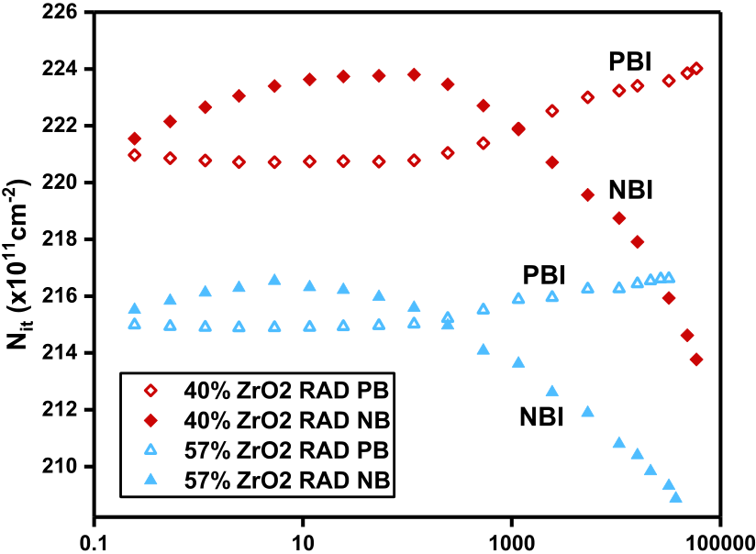



Fig. 8. *N*it as a function of total dose for Hf*x*Zr1−*x*O*y* S-passivated thin films under −0.5 or 0.5 V biased irradiation.

was increased in relative low dose level, while it was decrease at high does level. As discussed in Section III-C, the passiva-tion of Ge dangling bonds can lead to a decrease in interface trap density for Ge MOS capacitors, while the depassivation of passivated Ge-S bonds can lead to an increase in interface trap density for Ge MOS capacitors.

At a dose level smaller than 0.1 krad, the depassivation of passivated Ge-S bonds can be attributed to the H+protons drift from Ge substrate under NB [27]. At a total dose level larger than 0.1 krad, the passivation of Ge dangling bond dominated the interface trap density of Ge MOS capaci-tors. The result suggested that a large density of radiation-induced electrons are generated in oxide and transported to Ge interface to suppress the depassivation reaction [reaction (3)] during NBI.

As discussed in Section III-B, in order to further identify the variation of *N*it, the *N*it as a function of stress time for Hf*x*Zr1−*x*O*y* S-passivated thin films under −0.5 or 0.5 V biased irradiation were shown in Fig. 8. Similar to the result obtained in Fig. 7(c), the *N*it of Hf*x*Zr1−*x*O*y* with various Zr compositions was all increased during PBI, while the *N*it of the Hf*x*Zr1−*x*O*y* MOS capacitor was all increased in magnitude during NBI.

Fig. 9 shows the *I*–*V* characteristics of MOS capaci-tors with Hf0*.*43Zr0*.*57O2 and Hf0*.*6Zr0*.*4O2 gate dielectrics before and after the irradiation exposure. The result indicates that no significant discrepancy of leakage gate current can be observed before and after the irradiation exposure for both Hf0*.*43Zr0*.*57O2 and Hf0*.*6Zr0*.*4O2 capacitors. The result in Fig. 9 has a good agreement with the results obtained in the literature, which indicated that gate leakage current of MOS devices is insensitive to irradiation exposure. It was sug-gested that the radiation-induced oxide and interface trapped charges had no significant effects on leakage current. Another possible explanation is that the Hf*x*Zr1−*x*O*y* thin films are relative thick (∼20 nm). The irradiation exposure has no significant effect on the leakage behavior of MOS capacitors with high-*k* dielectrics larger than 10 nm. It is reported the radiation can induce leakage current in ultrathin gate oxides (4–7 nm) [34]–[36]. Electrons can tunnel through the oxide

2920 IEEE TRANSACTIONS ON NUCLEAR SCIENCE, VOL. 64, NO. 12, DECEMBER 2017

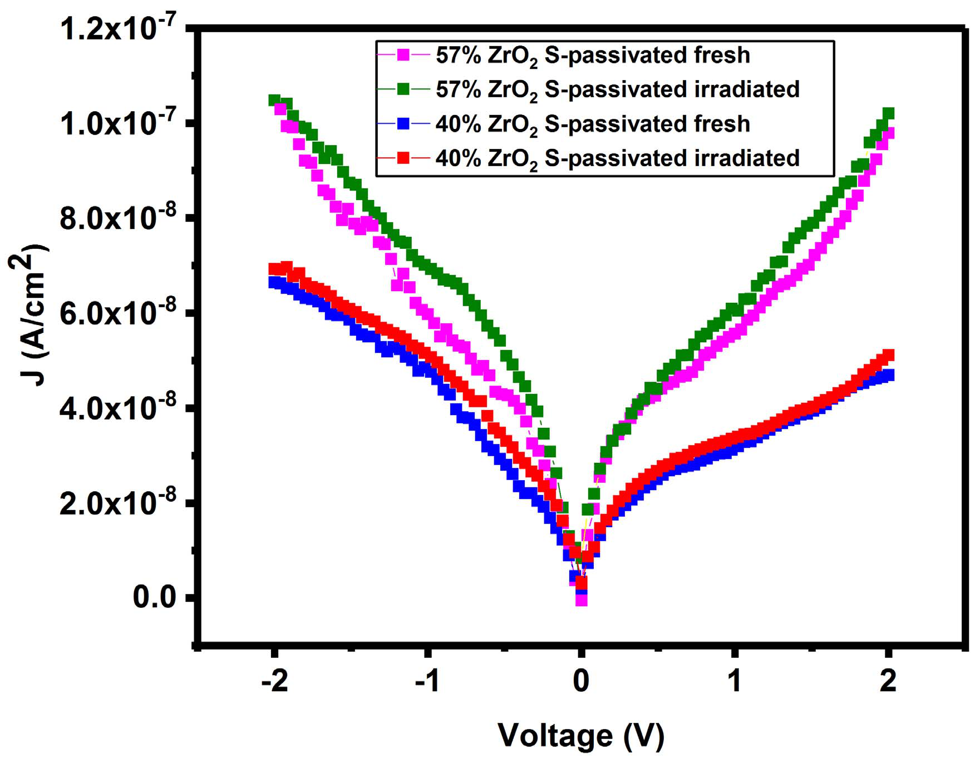

Fig. 9. before and after irradiation exposure. *J*–*V* Characteristics for Hf*x*Zr1−*x*O*y* dielectrics on Ge MOS devices

and be mediated by neutral oxide defects at low oxide field, which caused radiation induced leakage current [34]–[36]. For the relative thick gate oxide, the radiation-induced charges are difficult to tunnel the dielectric and enhance the gate leakage

[2] N. Raghavan, K. L. Pey, and K. Shubhakar, “High-*K*  dielectric breakdown in nanoscale logic devices—Scientific insight and tech- nology impact,” *Microelectron. Rel.*, vol. 54, no. 5, pp. 847–860, May 2014.

[3] G. D. Wilk, R. M. Wallace, and J. M. Anthony, “High-*k* gate dielectrics: Current status and materials properties considerations,” *J. Appl. Phys.*, vol. 89, no. 10, pp. 5243–5275, May 2001.

[4] N. Miyata, “Study of direct-contact HfO2/Si interfaces,” *Materials*, vol. 5, no. 3, pp. 512–527, Mar. 2012.

[5] J. Robertson, “Band offsets, Schottky barrier heights, and their effects on electronic devices,” *J. Vac. Sci. Technol. A, Vac. Surf. Films*, vol. 31, no. 5, p. 050821, Sep. 2013.

[6] C. C. Li *et al.*, “Improved electrical characteristics of Ge pMOSFETs with ZrO2/HfO2 stack gate dielectric,” *IEEE Electron Device Lett.*, vol. 37, no. 1, pp. 12–15, Jan. 2016.

[7] H.-S. Jung *et al.*, “Impacts of Zr composition in Hf1−*x*Zr*x*O*y* gate dielectrics on their crystallization behavior and bias-temperature-instability characteristics,” *IEEE Trans. Electron Devices*, vol. 58, no. 7, pp. 2094–2103, Jul. 2011.

[8] R. I. Hegde, D. H. Triyoso, S. B. Samavedam, and B. E. White, Jr.,“Hafnium zirconate gate dielectric for advanced gate stack applications,”*J. Appl. Phys.*, vol. 101, no. 7, p. 074113, 2007.

[9] T. S. Böscke, P. Y. Hung, P. D. Kirsch, M. A. Quevedo-Lopez, and R. Ramírez-Bon, “Increasing permittivity in HfZrO thin films by surface manipulation,” *Appl. Phys. Lett.*, vol. 95, no. 5, p. 052904, 2009.

[10] Y. Oshima, M. Shandalov, Y. Sun, P. Pianetta, and P. C. McIntyre,

|  |  |  |
| --- | --- | --- |
| current. | IV. CONCLUSION | “Hafnium oxide/germanium oxynitride gate stacks on germanium: |
| Capacitance scaling and interface state density,” *Appl. Phys. Lett.*, |
| vol. 94, no. 18, p. 183102, May 2009. |

We have examined the radiation response of Ge MOS capacitors with Hf*x*Zr1−*x Oy(*0*.*43 *< x <* 1*)* gate dielectrics under positive and NB. Gate leakage current density increased with the increasing of Zr composition in gate oxide, and decreased with the sulfur treatment of Ge surface. The den-sity of negative oxide trapped charge increases in magnitude with increasing Zr composition in Hf*x*Zr1−*x*O*y* during PB. Under NB,*N*ot of HfO2 was larger than that of Zr-containing Hf*x*Zr1−*x*O*y*. In addition, the difference of*N*ot between Hf0*.*43Zr0*.*57O2 and Hf0*.*6Zr0*.*4O2 was negligible. This implies that the concentration of oxygen vacancies and hole traps in Zr-containing Hf*x*Zr1−*x*O*y* is not strongly dependent on Zr composition. More interface traps were generated in Zr-doped Hf*x*Zr1−*x*O*y* compared to HfO2 under PB, which suggests that ZrO2 presented more hydrogen-related species than that of HfO2. Under PBI, the Zr-doped Hf*x*Zr1−*x*O*y* exhibited smaller *V*FB than that of HfO2. This is attributed to the depassi-vation of Ge-S bonds in capacitors incorporating HfO2 thin films, resulting in the build-up of interface traps. Under NBI, *V*FB was dependent on the combined effect of the net oxide trapped charge and interface traps at the Ge/high-k interface. The*V*FB evaluated in HfO2 Ge devices is much larger than that of the Si devices evaluated in our previous study. This can be explained by the large number of interface traps between the dielectric and the Ge substrate. This paper demonstrated that Hf*x*Zr1−*x*O*y* may be a promising candidate for space micro-electronics in specified bias conditions. However, the biased radiation environment is quite challenging for Ge devices, and future work will be required to identify the radiation hardness

[11] R. Zhang, T. Iwasaki, N. Taoka, M. Takenaka, and S. Takagi, “High-

mobility Ge pMOSFET with 1-nm EOT Al02O3/GeO*x*/Ge gate stack

fabricated by plasma post oxidation,” *IEEE Trans. Electron Devices*,

vol. 59, no. 2, pp. 335–341, Feb. 2012.

[12] T. F. Teng, S. Nachimuthu, W. H. Hung, and J. C. Jiang, “A first

principles study of H2S adsorption and decomposition on a Ge(100)

surface,” *RSC Adv.*, vol. 5, no. 5, pp. 3825–3832, 2015.

[13] S. Sioncke *et*  *al.*, “Atomic layer deposition of Al2O3 on

S-passivated Ge,” *Microelectron. Eng.*, vol. 88, no. 7, pp. 1553–1556,

Jul. 2011.

[14] C. X. Li, C. D. Wang, C. H. Leung, P. T. Lai, and J. P. Xu, “A study on

fluorine incorporation in Ge *p*-MOS capacitors with HfTiON dielectric,”

*Microelectron. Eng.*, vol. 86, nos. 7–9, pp. 1596–1598, Jul./Sep. 2009.

[15] M. Althobaiti *et al.*, “Hafnia and alumina on sulphur passivated germa-

nium,” *Vacuum*, vol. 122, pp. 306–309, Dec. 2015.

[16] M. Milojevic *et al.*, “Half-cycle atomic layer deposition reaction studies

of Al2O3 on (NH4)2S passivated GaAs(100) surfaces,” *Appl. Phys. Lett.*,

vol. 93, no. 25, p. 252905, Dec. 2008.

[17] D. Cao *et al.*, “Total-dose radiation response of HfLaO films prepared

by plasma enhanced atomic layer deposition,” *IEEE Trans. Nucl. Sci.*,

vol. 60, no. 2, pp. 1373–1378, Apr. 2013.

[18] N. Martinez, O. Gilard, and G. Quadri, “Total dose effects:

A new approach to assess the impact of radiation on device reli-

ability,” *IEEE Trans. Nucl. Sci.*, vol. 60, no. 3, pp. 2266–2271,

Jun. 2013.

[19] G. X. Duan *et al.*, “Bias dependence of total ionizing dose effects in

SiGe-SiO2/HfO2 pMOS FinFETs,” *IEEE Trans. Nucl. Sci.*, vol. 61,

no. 6, pp. 2834–2838, Dec. 2014.

[20] D. K. Chen *et al.*, “Total dose response of Ge MOS capacitors with

HfO2/Dy2O3 gate stacks,” *IEEE Trans. Nucl. Sci.*, vol. 54, no. 4,

pp. 971–974, Aug. 2007.

[21] J. A. Felix *et al.*, “Total-dose radiation response of hafnium-silicate

capacitors,” *IEEE Trans. Nucl. Sci.*, vol. 49, no. 6, pp. 3191–3196,

Dec. 2002.

[22] Y. Mu *et al.*, “Real-time and on-site *γ* -ray radiation response testing

system for semiconductor devices and its applications,” *Nucl. Instrum.*

*Method Phys. Res. B, Beam Interact. Mater. Atoms*, vol. 372, pp. 14–28,

Apr. 2016.

|  |  |  |  |  |  |  |  |  |  |  |  |  |  |  |
| --- | --- | --- | --- | --- | --- | --- | --- | --- | --- | --- | --- | --- | --- | --- |
| of these devices. | | | | | REFERENCES | | | | gate | oxides | | for | metal | [23] L. F. Mao, “Investigating the effects of the interface defects on the |
| gate leakage current in MOSFETs,” *Appl. Surf. Sci.*, vol. 254, no. 20, |
| pp. 6628–6632, Aug. 2008. |
| [1] J. | Robertson, | | | “High |
| [24] C. Z. Zhao *et al.*, “Stress-induced positive charge in Hf-based gate |
| dielectric | | constant | |
| dielectrics: Impact on device performance and a framework for the |
| oxide | | Si | transistors,” | | *Rep.* | *Prog.* | | *Phys.*, | vol. | 69, | pp. | 327–396, | | defect,” *IEEE Trans. Electron Devices*, vol. 55, no. 7, pp. 1647–1656, |
| Dec. 2006. | | | | | Jul. 2008. |

MU *et al.*: TOTAL DOSE EFFECTS AND BIAS INSTABILITIES OF (NH4*)*2S PASSIVATED Ge MOS CAPACITORS 2921

[25] C. Z. Zhao, J. F. Zhang, M. B. Zahid, B. Govoreanu, G. Groeseneken, and S. De Gendt, “Determination of capture cross sections for as-grown electron traps in HfO2/HfSiO stacks,” *J. Appl. Phys.*, vol. 100, no. 9, p. 093716, Nov. 2006.

[26] Y. Mu *et al.*, “Total ionizing dose response of hafnium-oxide based MOS devices to low-dose-rate gamma ray radiation observed by pulse cv and on-site measurements,” *IEEE Trans. Nucl. Sci.*, vol. 64, no. 1, pp. 673–682, Dec. 2016.

[27] X. J. Zhou, D. M. Fleetwood, L. Tsetseris, R. D. Schrimpf, and S. T. Pantelides, “Effects of switched-bias annealing on charge trapping in HfO2 gate dielectrics,” *IEEE Trans. Nucl. Sci.*, vol. 53, no. 6, pp. 3636–3643, Dec. 2006.

[28] J. X. Zhang *et al.*, “Impact of bias conditions on total ionizing dose effects of60Co*γ* in SiGe HBT,” *IEEE Trans. Nucl. Sci.*, vol. 63, no. 2, pp. 1251–1258, Apr. 2016.

[29] M. N. U. Bhuyian *et al.*, “Impact of cyclic plasma treatment on oxygen vacancy defects in TiN/HfZrO/SiON/Si gate stacks,” *Appl. Phys. Lett.*, vol. 106, no. 19, p. 193508, May 2015.

[30] K. Onishi *et al.*, “Bias-temperature instabilities of polysilicon gate HfO2 MOSFETs,” *IEEE Trans. Electron Devices*, vol. 50, no. 6, pp. 1517–1524, Jun. 2003.

[31] E. H. Nicollian and A. Goetzberger, “The Si-SiO2 interface— Electrical properties as determined by the metal-insulator-silicon con- ductance technique,” *Microelactron. Rel.*, vol. 7, no. 2, pp. 1055–1133, 1968.

[32] D. K. Schroder, *Semiconductor Material and Device Characterization*. Hoboken, NJ, USA: Wiley, 2006, ch. 6.3.

[33] V. A. K. Raparla, S. C. Lee, R. D. Schrimpf, D. M. Fleetwood, and K. F. Galloway, “A model of radiation effects in nitride–oxide films for power MOSFET applications,” *Solid-State Electron.*, vol. 47, no. 5, pp. 775–783, May 2003.

[34] L. Larcher, A. Paccagnella, M. Ceschia, and G. Ghidini, “A model

|  |  |  |  |  |  |  |  |  |
| --- | --- | --- | --- | --- | --- | --- | --- | --- |
| of | radiation | induced | leakage | current | (RILC) | in | ultra-thin | gate |

oxides,” *IEEE Trans. Nucl. Sci.*, vol. 46, no. 6, pp. 1553–1561, Dec. 1999.

[35] M. Ceschia, A. Paccagnella, A. Cester, A. Scarpa, and G. Ghidini,“Radiation induced leakage current and stress induced leakage current in ultra-thin gate oxides,” *IEEE Trans. Nucl. Sci.*, vol. 45, no. 6, pp. 2375–2382, Dec. 1998.

[36] A. Scarpa *et al.*, “Ionizing radiation induced leakage current on ultra-thin gate oxides,” *IEEE Trans. Nucl. Sci.*, vol. 44, no. 6, pp. 1818–1825, Dec. 1997.